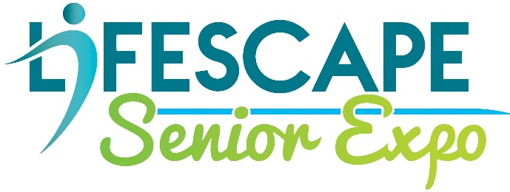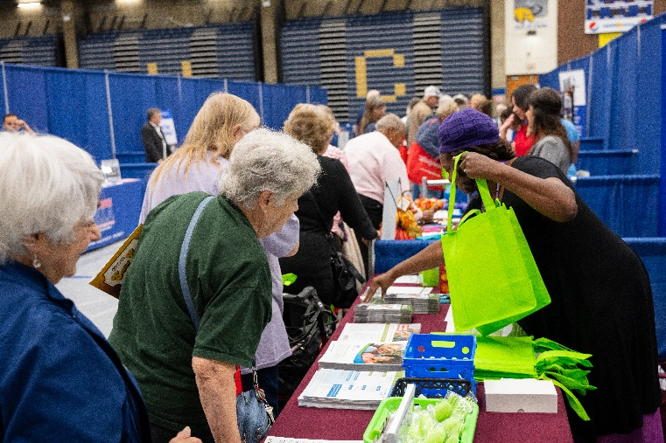

Lifescape Senior Expo 2024
MARKETING OPPORTUNITIES
Your chance to reach older adults and their families one-on-one and share information about products and services they may need!

LIFESCAPE SENIOR EXPO – A Community Resource for Older Adults
Saturday, September 21, 2024

The Lifescape Senior Expo typically features more than 75 local businesses as exhibitors, a keynote speaker, and a vaccination clinic.

This year’s Senior Expo will be held at the Rock Valley College PE Center. The college features ample parking and easy access for exhibitors and attendees.

A variety of exhibitors participate, including healthcare providers, insurance agencies, home health care companies, hospice services, financial planning experts, funeral homes, and home improvement contractors. The Lifescape Senior Expo provides a great avenue to showcase your information, services, and products to older adults and their family members.

Senior Expo is your unique opportunity to build relationships with NEW and existing customers! Please let us know if you have any questions.

MARKETING DETAILS: LIFESCAPE SENIOR EXPO -- A Community Resource for Older Adults

PRESENTING SPONSORSHIP - $7,500
- Your company name/logo will be recognized as the presenting sponsor in all Expo marketing materials (ie: “Lifescape Senior Expo Presented by YOUR COMPANY”)
- Four (4) complimentary exhibit spaces with priority placement
- Full-page image in Senior EXPO Resource Guide
- Mentions in all issues of Lifescape’s hard copy or e-Newsletter, including your logo, during the year of the sponsorship
- Placement of your logo as a PRESENTING SPONSOR on all EXPO social media posts, flyers, emails blasts, advertising, and website listings
- Inclusion on all event press releases
- FREE add-ons for your booth (chairs, electric, etc.)
- Your logo featured as presenting sponsor on a sponsor banner

GOLD SPONSORSHIP - $5,000
- Three (3) complimentary exhibit spaces with priority placement
- Full-page image in Senior EXPO Resource Guide
- Mentions in all issues of Lifescape’s hard copy or e-Newsletter, including your logo, during the year of the sponsorship
- Placement of your logo as a GOLD SPONSOR on all EXPO social media posts, flyers, emails blasts, advertising, and website listings
- FREE add-ons for your booth (chairs, electric, etc.)
- Your company name/logo listed as a Gold sponsor on a sponsor banner

SILVER SPONSORSHIP - $2,500
- Two (2) complimentary exhibit spaces with priority placement
- Half-page image in Senior EXPO Resource Guide
- Mentions in one (1) issue of Lifescape’s hard copy or e-Newsletter, including your logo, during the year of the sponsorship
- Placement of your logo as a SILVER SPONSOR on all EXPO social media posts, flyers, emails blasts, advertising, and website listings
- FREE add-ons for your booth (chairs, electric, etc.)
- Your company logo/name listed as a Silver sponsor on a sponsor banner

BRONZE SPONSORSHIP - $1,500
- One (1) complimentary exhibit space with priority placement
- Quarter-page image in Senior EXPO Resource Guide
- Placement of your logo as a BRONZE sponsor on all EXPO advertising and promotional materials.
- Your company logo/name listed as a Bronze sponsor on a sponsor banner
- FREE add-ons for your booth (chairs, electric, etc.)

A FRIENDS OF LIFESCAPE - $500
- This shows that YOU SUPPORT LIFESCAPE COMMUNITY SERVICES and the benefit Lifescape brings to our community.
- Your name listed in the Senior EXPO Resource Guide.
- Your company logo/name listed as a Friend of Lifescape on a sponsor banner

Lifescape Community Services is a 501(c)(3) nonprofit, which means your support and marketing dollars are tax deductible!

For more information, please contact Heather Carr, Fund Development/Marketing Director at 815-490-1103 or hcarr@lifescapeservices.org.

Empowering Older Adults to Choose Lives of Independence and Dignity

